
Name: Janushiya P A
Reg No: 1924260368
Course Code: CSA0224
Course Name: C Programming

TASK 9 – IMPLEMENT AND TEST THE BILLING PROGRAM
Bloom’s Level: K3 – Apply

1. Aim
To implement and test a C electricity billing program using slab rates, validate meter readings, handle meter rollover, and verify the correctness of bill calculations.

2. Algorithm
- Start.
- Read the previous and current meter readings.
- Validate the inputs and ensure both readings are between 0 and 65,535.
- If the current reading is lower, check whether a valid rollover has occurred.
- Calculate the units consumed.
- Calculate the bill using the fixed charge and slab rates.
- Display the units consumed and the bill amount.
- Stop.

3. Complete C Program

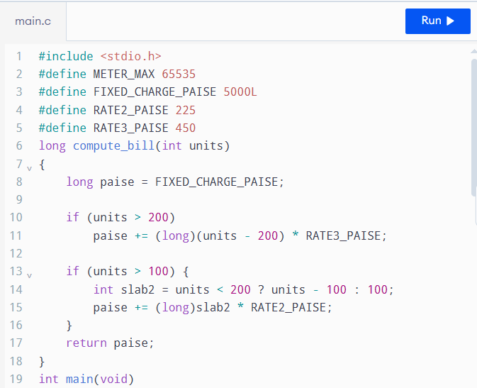

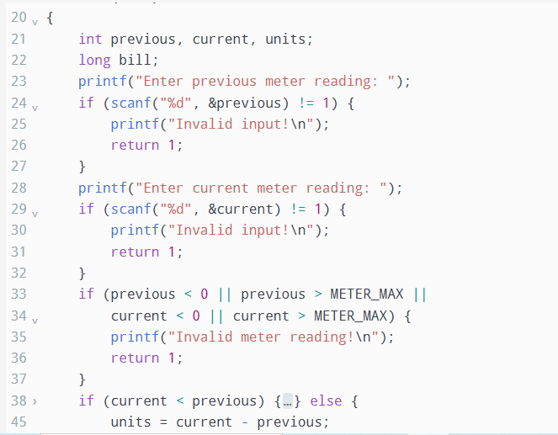

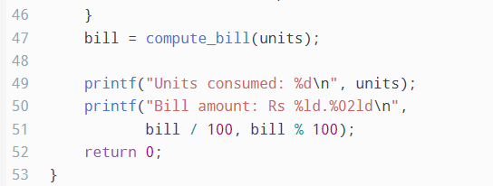

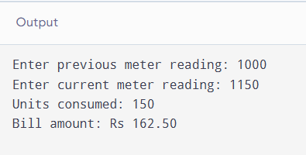

4. Test Cases and Results
The following expected results use a fixed charge of ₹50, the first 100 units free, the next 100 units at ₹2.25 per unit, and units above 200 at ₹4.50 per unit.
Test | Input (previous, current) | Expected result
Zero units | 1000, 1000 | ₹50.00
Exactly 100 units | 1000, 1100 | ₹50.00
150 units | 1000, 1150 | ₹162.50
Exactly 200 units | 1000, 1200 | ₹275.00
350 units | 1000, 1350 | ₹950.00
Meter rollover | 65400, 120 | 256 units; ₹302.00
Invalid letters | abc, any value | Invalid input
Negative reading | -10, 100 | Invalid meter reading
Invalid decrease | 1000, 900 | Rollover not accepted
Note: The rollover validation uses 65,000 as a practical threshold for this exercise. A real meter system should follow the meter manufacturer's rollover and fault-detection rules.

5. Five-Bill Calculation
Consider five bills for consumption of 0, 100, 150, 200, and 350 units.
Units | Bill amount
0 | ₹50.00
100 | ₹50.00
150 | ₹162.50
200 | ₹275.00
350 | ₹950.00
Total | ₹1,487.50
The total is calculated by adding all five bill amounts manually. The program can be tested with the corresponding meter readings from the previous table.

6. Alternative Concept – Arrays and Loops
Instead of fixed if statements, the tariff limits and rates can be stored in arrays. A loop can calculate the charge for each slab.
For example:
int limits[] = {100, 200};
int rates[] = {0, 225, 450};
The program would iterate through the slabs, calculate the units falling within each slab, and add the corresponding charge.
- Fixed if statements: A constant number of checks, giving O(1) time per bill for a fixed tariff structure.
- Array and loop method: O(s) time per bill, where s is the number of slabs.
- Extra space: O(s) to store the limits and rates.
- Maintainability: Arrays and loops are easier to update when the number of tariff slabs changes.

7. Result
The electricity billing program was implemented using C. Normal slab calculations, boundary values, meter rollover, and invalid inputs were considered. The five-bill total was calculated as ₹1,487.50, and the program's results can be compared with the expected values in the test table.

